*Attendance System Using Facial Recognition*

Prof. Dr. S.T. Patil  
Department Of Computer science  
Vishwakarma Institute Of TechnologyPune,India  
shrishailappa.patil@vit .edu

Shreyash Palresha  
Department Of Computer Science  
Vishwakarma Institute Of TechnologyPune,India  
shreyash.palresha17@vit.edu Sachin Iyer  
Department Of Computer Science  
Vishwakarma Institute Of TechnologyPune,India  
sachin.iyer17@vit.edu

Syed Nuaym Asfan  
Department Of Computer Science  
Vishwakarma Institute Of TechnologyPune,India  
nuaym.syed17@vit.edu Himanshu Kale  
Department Of Computer Science  
Vishwakarma Institute Of TechnologyPune,India  
himanshu.kale17@vit.edu

*Abstract*— Face recognition techniques are being widely used and have a huge scope for future use if detected accurately. This work details a real-time for automated attendance system which will mark attendance of users (students and employees of workplaces and institutes). This system is a real-world solution to handle everyday activities of organizations. The main task is recognizing the faces of the detected person with high accuracy. The automated system maintains the attendance records of student. The system enrolls the student’s face into the database against the students’s ID (unique) and Name. The system then allots attendance to the recognized faces in the database.

1.Introduction

One of the most common and frequent problem everyone has about college attendance system is the old methods of attendance. Roll call is taken by calling each persons names , and we tend to reply in affirmation to prove our attendance. It’s a long and tedious routine in educational institutions and several people have manipulated the manual attendance system(e.g. proxy attendance, attendance miss, wrong attendance,, no proper record of attendence). Attendance being a very important side of administration might usually become a time constraint, repetitive job, leading itself to inaccuracies. Organizations need to keep a track of students or employees inside the organization like staff and students to maximize their performance. Managing student’s attendance at lecture periods has become a tough challenge. The ability to work out the attendance proportion becomes a significant task as manual computation produces errors, and wastes a great deal of our time. The basis of developing an automatic

attendance management system is to computerize the standard method of taking attendance. The proposed system strives to outgrow the constraints of the existing systems .

**II. LITERATURE SURVEY**

**A. Summary of Approaches**

**1) Biometric scan**

i. Students fingerprints are scanned and stored in the database.

ii. To mark their attendance the students must use the biometric system before every class.

iii. A central system holds all the data and is responsible for managing all student records.

**2) ID card swipe system**

i. College ID cards are fitted with RFID chips which are scanned by readers installed in each classroom.

ii. The cards are scanned before each class to mark the student’s attendance.

iii. The server is updated every ten minutes

iv. Every teaching faculty gets a list of all the students who were present after every class is over.

v. An online portal allows access to students to view their current attendance.

**3) Iris Based Recognition System**

i. Iris of employees is scanned by scanners installed in front of each classroom.

**B. EXISTING SYSTEMS**

# **1) Eigen face**

# i. This algorithm extracts the necessary information from an image and efficiently encodes it.

# ii. To obtain variations, a number of pictures of a single person is taken.

# iii. For the set of images of faces, eigenvectors and its covariance matric is calculated and stored.

# iv. Since every image represents an eigen vector, the data set helps produce variety for the system.

# v. A representation of these eigen vectors is called eigen faces.

# **2) Line Edge Map**

# i. One of the popular methods is using the Line Edge Maps algorithm.

# ii. In this method line matching is done to map the features of the face.

# iii. This algorithm mainly uses the most prominent features of the face; mainly the eyes, nose and mouth having high characteristics.

# iv. The colour images are converted to greyscale to observe and extract the similarities in the faces.

# v. Sobel edge detection algorithm is made use of to encode the greyscale images into binary edge maps.

# vi. This technique was developed by studying how we human beings remember other people’s faces (remembering face’s prominent features).

# **3) Histogram of oriented gradients (HOG)**

# i. This technique can be applied to detecting objects as well as faces.

# ii. All images used are converted to greyscale and every pixel in this image in assigned an integer.

# Iii. Every pixel compares its value to its neighbouring pixels.

# iv. The primary motive is to find the dark regions of the face in the image.

# v. The direction pointing to that dark region will have a white arrow pointing towards it.

# vi. This treatment is done for each pixel of the picture.

**III.PROPOSED SYSTEM**

Proposed automated attendance system can be divided into few modules.

**Image capture**: Camera will capture the image of the students at the beginning, after capturing the image the next process is to detect the image, for that it goes to the face detection.

**Face Detection**: The face detection algorithm will increase the efficiency of the face recognition. There are some of the algorithms proposed for face detection.

**Database Development**: In every individual requirement biometric based system enrolment can be chosen. In this phase we consider the image capture to way person as individual features. We extract the face and store the features in the database after identifying.

**Proposed Algorithm**:

1. The person’s image will be captured.

2. Apply detection algorithms for detecting the face.

3. Face recognition is going to be recognized.

4. Apply pre-processing image.

5. If enrolment phase Then store in database Else Apply feature extraction Apply for classification End if

6. Post-processing.

**IV. APPLICATIONS**

**A. Institutions**

Institutions have the traditional way of marking attendance where call out each student name to check if they are present. This method of roll call is time consuming and tedious. By using Facial Recognition, the process of taking attendance can be significantly improved to save time and provide a hassle-free way to automatically mark attendance. Since the number of students in an institution are more, using an automated system improves the productivity and standard of the college.

**B.Companies**

In most companies, employees have the practice of using their biometrics or ID card to log their time of entry and exit. During the peak hours the number of people entering and exiting the office are generally high. This causes congestion in the workplace and people queue up to and await their turn. Facial Recognition systems provide a more convenient way of managing this process of attendance. Employees don’t have to worry about logging their time as it’s an automatic process. The system will note the time of entry and exit when an employee enters or exits the office.

**C.Prison**

In prisons, everyday a head count of the prisoners is done to check if all inmates are present. Using facial recognition to automate this process of doing head count the increases the efficiency and reliability is improved. The security also increases as tabs can always be kept on each prisoner .

**IV. SYSTEM DESIGN**

**A. Activity diagram**

The System process can be separated into three working modules. They are face representation, feature extraction and classification. The first and foremost task is modelling a face. The way is face is represented determines the next two steps. The image acquired is transformed to match the positions of images already present. In feature extraction the features of the face are mapped as histograms with gradients and they are stored as binary values. The final step is recognizing a familiar face. The system compares the face seen in the camera with records that are already stored.

**B. Data Flow Diagram**

Images from a live stream are passed as input to the system. These images are converted to greyscale as LBPH works with images in greyscale. From the greyscale images features of the face are extracted. Features refer to the gradients in the face. The features are then compared with existing records to check if there is a match. If the face matches it is displayed and output is in the form of attendance being marked for the person whose face was recognized.

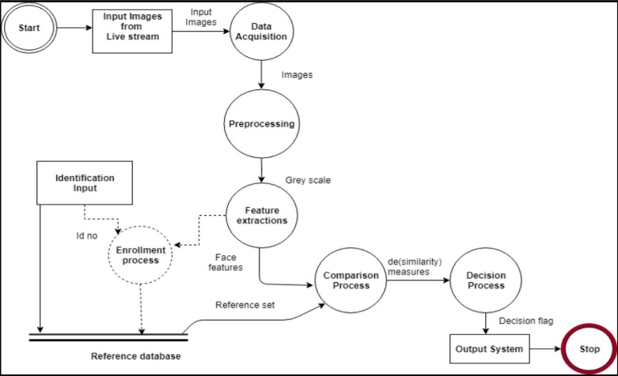

**Fig1: Flow of data in the System**

**V. IMPLEMENTATION**

1. **Algorithm**

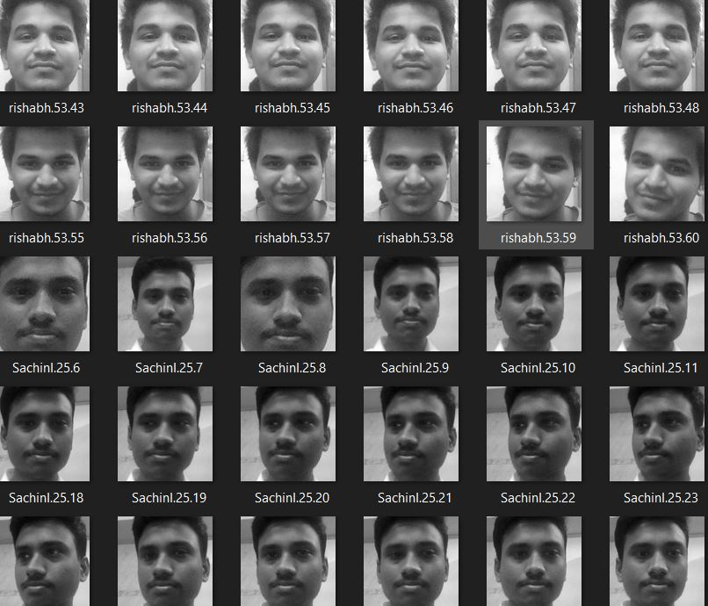

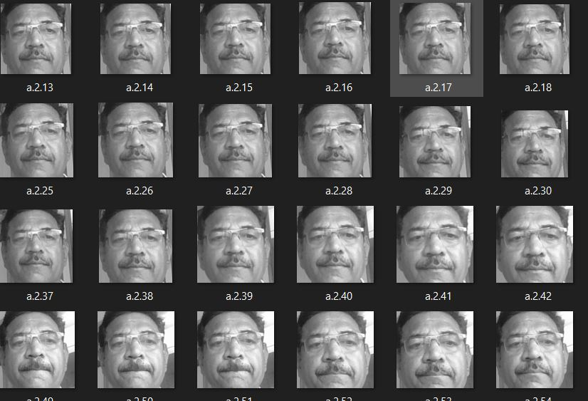

**Fig2 & Fig3: Images stored in greyscale**

1. **LBPH algorithm:**

LBPH stands for Local Binary Pattern Histogram, a basic algorithm that’s used to detect faces from the front side. It is used for object as well as face detection. The LBP operator helps to get local features by Local Binary Pattern acts. The local special arrangement of the face is shortened by these LBP acts. The LBP operator divides the face in the image into pixels. Every pixel is associated with 8 neighbour pixels that surrounds it. Each pixel value

is then compared with the surrounding neighbour pixel values.

1. **The Face Recognition Algorithm**

**Input:** A person’s face.

**Output:** Attendance is marked for recognized faces.

**Initialization**

1. Open the camera cv2.VideoCapture(0)

2. Import the face classifier LBPHFaceRecognizer_create() .

3. Read the trained data from the file recognizer.read('trainer.yml').

**GPU Part**

1. Image is captured frame by frame img = cap.read()

2. Face in the frame is converted to greyscale gray = (img, cv2.COLOR_BGR2GRAY)

3. All faces are detected in the frame faces = face_cas.detectMultiScale()

4. for coordinates of face: 1) values inside frame are read roi_gray = gray[y:y + h, x:x + w] 2) values are compared with stored values confidence = recognizer.predict(roi_gray)

5. if confidence<75:

face matching with the values is recognized attendance is marked dataEntry(name,class_count)

6. else:

face is not recognized id = 'Unknown'

1. **Processes involved**
2. **Pre-Processing Images**

The system captures lots of images (approx. 50) of every individuals face. The images are converted into grey scale as LBPH operates using images in greyscale and the images are stored in a folder. The stored images will be saved with a name and ID unique to that person.

**2. Face Detection**

When a person appears in front of the camera, the camera detects that a face is present and a frame appears around the face. The entire frame is converted to greyscale as LBPH works only on greyscale images. A scale factor is used to compensate for multiple faces present in front of the camera.

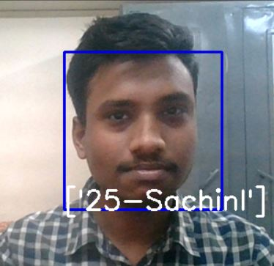

**Fig4: Frame around detected face with ID**

1. **Feature Extraction**

The LBPH algorithm makes use of binary values and stores the data in a file. The binary values are different for each face. The Region of Interest (ROI) are parts of the face from where features are extracted. Information about the gradients in the face is captured. The image of a person’s face is divided cells comprising of 8 pixels. Each pixel present has a gradient and compares itself with its neighbour pixels.

**Fig5: Example of features**

**Fig6: Extracting the Histograms**

1. **Face Recognition**

In the comparison module, face recognition process is carried out. When a face is detected by the camera it checks the corresponding values of the current visible face with values stored in the file. If the values are a match, then the face is recognized, and the name associated with that face is displayed.

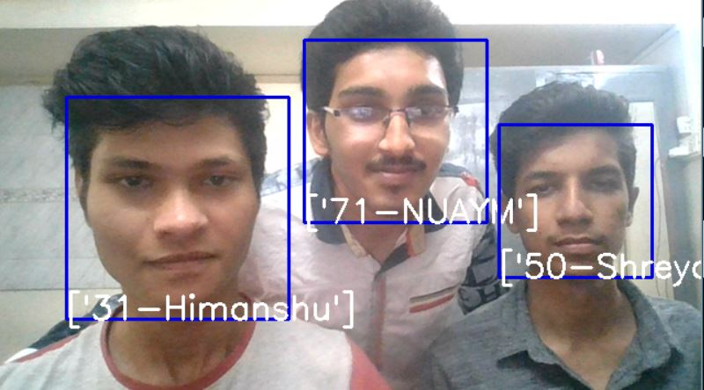

**Fig7: Multiple faces recognized with ID**

**C. Database**

Database holds the name and ID of all people whose attendance will have to be marked. As and when a face is detected and matched with the existing records, the attendance is automatically updated in the database.

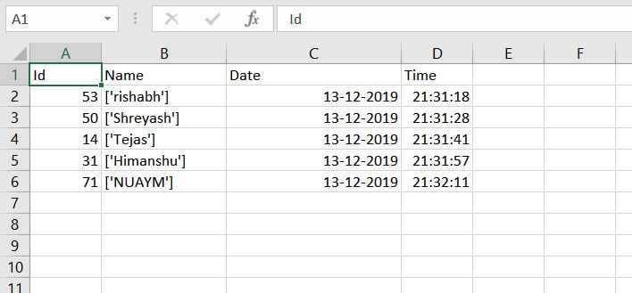

**Fig8: Attendance marked in the database**

**EVALUATION**

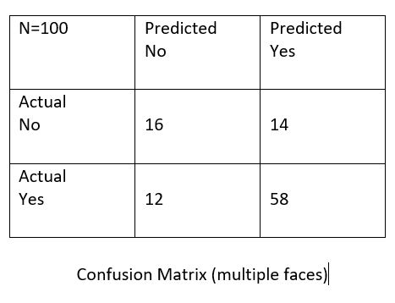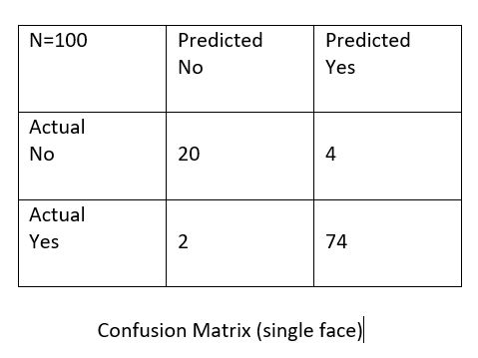

**Fig9 and Fig10: Confusion matrix**

**5 . FURTHER DEVELOPMENT**

The system can be useful in many other areas and can replace the existing systems of attendance marking. Sometimes the poor lighting condition of the classroom may affect image quality which indirectly degrades system performance, this can be overcome in the latter stage by improving the quality of the video or by using some algorithms (i.e. tensorflow, keras,deepID and pytorch).

**6.CONCLUSION**

Thus, the aim of this paper is to capture the video of the students, convert it into frames, relate it with the database to ensure their presence or absence, mark attendance to the particular student to maintain the record. The Automated Classroom Attendance System helps in increasing the accuracy and speed ultimately to achieve the high-precision real-time attendance to meet the need for automatic classroom evaluation

**Acknowledgement**

We would like to thank Prof. Dr. S.T. Patil for encouraging us and giving us an opportunity to implement this project and gave us knowledgeful insight and the right motivation to complete this project**.**

**8 . REFRENCE**

1. 1. N.Sudhakar Reddy, M.V.Sumanth, S.Suresh Babu, "A
2. Counterpart Approach to Attendance and Feedback System
3. using Machine Learning Techniques",Journal of Emerging
4. Technologies and Innovative Research (JETIR), Volume 5,
5. Issue 12, Dec 2018.
6. 2. Dan Wang, Rong Fu, Zuying Luo, "Classroom Attendance
7. Auto-management Based on Deep Learning",Advances in
8. Social Science, Education and Humanities Research, volume
9. 123,ICESAME 2017.
10. 3. Akshara Jadhav, Akshay Jadhav, Tushar Ladhe, Krishna
11. Yeolekar, "Automated Attendance System Using Face
12. Recognition", International Research Journal of Engineering
13. and Technology (IRJET), Volume 4, Issue 1, Jan 2017.
14. 4. B Prabhavathi, V Tanuja, V Madhu Viswanatham and M
15. Rajashekhara Babu, "A smart technique for attendance system
16. to recognize faces through parallelism", IOP Conf. Series:
17. Materials Science and Engineering 263, 2017.
18. 5. Prajakta Lad, Sonali More, Simran Parkhe, Priyanka Nikam,
19. Dipalee Chaudhari, " Student Attendance System Using Iris
20. Detection", IJARIIE-ISSN(O)-2395-4396, Vol-3 Issue-2
21. 2017.
22. 6. Samuel Lukas, Aditya Rama Mitra, Ririn Ikana Desanti, Dion
23. Krisnadi, "Student Attendance System in Classroom Using
24. Face Recognition Technique", Conference Paper DOI:
25. 10.1109/ICTC.2016.7763360, Oct 2016.
26. 7. K.Senthamil Selvi, P.Chitrakala, A.Antony Jenitha, "Face
27. Recognition Based Attendance Marking System", IJCSMC,
28. Vol. 3, Issue. 2, February 2014.
29. 8. Yohei KAWAGUCHI, Tetsuo SHOJI, Weijane LIN, Koh
30. KAKUSHO, Michihiko MINOH, "Face Recognition-based
31. Lecture Attendance System", Oct 2014.
32. 9. Shireesha Chintalapati, M.V. Raghunadh, "Automated
33. Attendance Management System Based On Face Recognition
34. Algorithms", IEEE International Conference on
35. Computational Intelligence and Computing Research, 2013.
36. 10. B. K. Mohamed and C. Raghu, “Fingerprint attendance
37. system for classroom needs,” India Conference (INDICON),

Annual IEEE, pp. 433–438, 2012.

1. 1. Abate A. F., Nappi M., Riccio D. and Sabatino G., "2D and
2. 3D
3. face recognition: A survey", Pattern Recognition Letters,
4. 28(14), 1885-1906 (2007)
5. 2. Kosov S., Scherbaum K., Faber K., Thormahlen T. and Seidel
6. H.-P., "Rapid stereo-vision enhanced face detection", Image
7. Processing (ICIP), 2009 16th IEEE International Conference
8. on, IEEE, 1221-1224 (2009)
9. 3. Zhao W., Krishnaswamy A., Chellappa R., Swets D. L. and
10. Weng J., "Discriminant analysis of principal components for
11. face recognition", Face Recognition, Springer 73-85.(1998)
12. 4. Kanade T., "Picture processing system by computer complex
13. and recognition of human faces", (1974)
14. 5. Levada A., Correa D., Salvadeo D., Saito J. and Mascarenhas
15. N., "Novel approaches for face recognition: templatematching
16. using dynamic time warping and LSTM NeuralNetwork
17. Supervised Classification", Systems, Signals and
18. Image Processing, 2008. IWSSIP 2008. 15th International
19. Conference on, IEEE, 241-244 (2008)
20. 6. T.Kanade, “Picture processing by computer complex and
21. recognition of human faces,” technical report, Dept.
22. Information Science, Kyoto Univ., 1973.
23. 7. R. Bruneli and T. Poggio, “Face recognition: features versus
24. templates,” IEEE Trans. Pattern Analysis and Machine
25. Intelligence, vol. 15, pp. 1042-1052, 1993.
26. 8. V. Blanz and T. Vetter, “Face recognition based on fitting a
27. 3D morphable model,” IEEE Trans. On Pattern